**CROP RECOMMENDATION**

**Introduction to DATA SET**

Crop prediction is an application of machine learning that aims to predict the most suitable crop to cultivate based on various environmental and soil factors. It is a valuable tool for farmers and agricultural professionals to make informed decisions and optimize agricultural practices. This ML models offer several benefits. They help optimize resource allocation by suggesting crops that are likely to thrive in specific conditions, leading to increased productivity and reduced costs. They also aid in crop rotation planning, disease and pest management, and overall decision-making in agriculture.

**Variables:**

N (Nitrogen): Nitrogen is one of the essential nutrients required for plant growth. The nitrogen level in the soil can impact the growth and development of crops. Higher nitrogen levels can promote lush foliage and vigorous growth, while low nitrogen levels can result in stunted growth. The N feature provides information about the nitrogen content in the soil.

P (Phosphorus): Phosphorus is another vital nutrient for plants, especially in their early stages of growth. It plays a crucial role in root development, flowering, and fruiting. The P feature represents the phosphorus level in the soil, which helps the model understand the availability of this nutrient for the crops.

K (Potassium): Potassium is essential for various physiological processes in plants, including photosynthesis, water regulation, and disease resistance. The K feature indicates the potassium level in the soil, which influences the plant's overall health and productivity.

Temperature: Temperature is a crucial environmental factor that affects plant growth and development. Different crops have specific temperature requirements for optimal growth. The temperature feature provides information about the average temperature in the growing region, which helps the model determine suitable crop choices based on temperature preferences.

Humidity: Humidity refers to the amount of moisture present in the air. It affects plant transpiration and water uptake, which impact plant growth and yield. The humidity feature indicates the average humidity levels in the growing region, allowing the model to consider crops that thrive in specific humidity conditions.

pH: pH is a measure of the acidity or alkalinity of the soil. Different crops have different pH preferences, and soil pH directly affects nutrient availability to plants. The pH feature provides information about the soil's pH level, aiding the model in recommending crops suitable for specific pH ranges.

Rainfall: Rainfall is a critical factor for plant growth as it provides water essential for photosynthesis, nutrient uptake, and overall plant health. The rainfall feature represents the average amount of rainfall in the growing region, helping the model identify crops that require specific water requirements.

**Interpreting** **the results:**  
The given dataset has 22 crops whose growth depends upon the variables described. Depending on the different quantities of nutrients in soil, and weather conditions, the model recommends different crops to the farmer.

• This fitted model shows that, holding all other features constant, humidity has the highest positive effect on crop selection being 0.19 in the model

• The coefficient for temperature is 0.11 which also shows tight coupling.

• N, P, K, and ph has a negative correlation with respect to targeted column.

• Rainfall has minimum positive effect on crop selection.

• If the soil has maximum nitrogen content then the soil is recommended for cotton.

• Phosphorus has maximum negative correlation -0.49 on crop selection.

The rest of the results can be seen in correlation matrix.

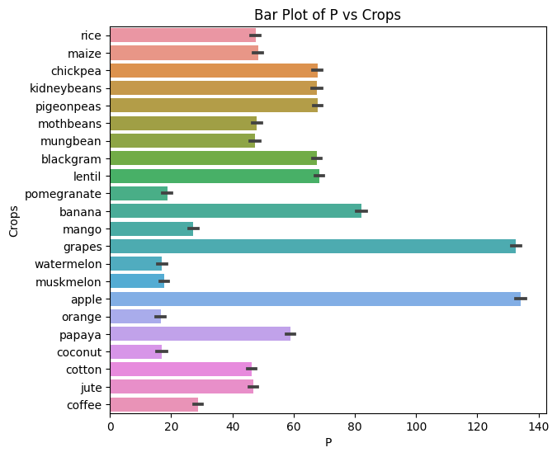

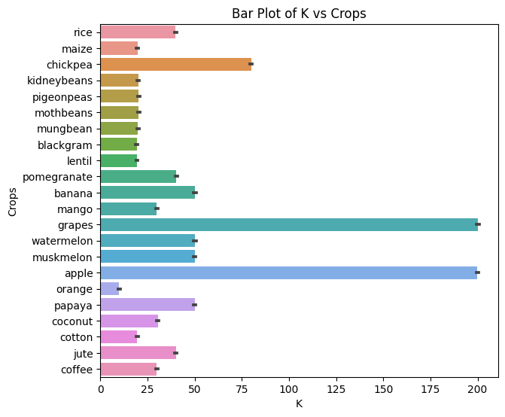

**Conclusions**   
• Nitrogen has highest effect on cotton. As the amount of N increases in soil, the soil becomes more favourable for crops like cotton, coffee, muskmelon & banana.

• Phosphorus has highest effect on apple. As the amount of P increases in soil, the soil becomes more favourable for crops like apple & grapes.

• Potassium has highest effect on apple. As the amount of K increases in soil, the soil becomes more favourable for crops like apple & grapes.

• Temperature is also a deciding factor in crop recommendation. Crops like papaya, mango & black gram require higher temperatures (around 30 deg.) for growth. While chickpeas, kidney beans and apples require temperatures below 25 deg.

• Crops like coconut, papaya, orange and muskmelons require higher humidity percentage i.e. around 90 & crops like chickpeas and kidney beans require very low humidity percentage i.e. around 22.

• We can conclude that almost all the crops in this dataset require ph between 6 & 7.

Chickpeas and coconuts require ph>7.

• Rice requires maximum rainfall around 240mm. While muskmelon requires least amount of rainfall.